**ResNet overview**

References:

<https://arxiv.org/pdf/1512.03385.pdf>

<https://cs231n.github.io/convolutional-networks/>

Slides

RESidual NETwork is a CNN architecture developed in 2015 (circa). It may present variations in its structure regarding the number of layers, in our project we’ve used a ResNet 32 optimized on CIFAR dataset.

The peculiarities of ResNet are:

* Skip connections (these are used in order to address the vanishing gradient issues when the depth of the net is huge) => bring the input together with the output (Residual network idea)
* Heavy use of batch normalization
* It misses a FC layer at the end
* State of arts atm regarding CNN

Pros & cons

+ very good accuracy

- heavy to train

Idea of residual networks: layers as learning residuals functions with reference to the layer inputs, instead of learning unreferenced functions.

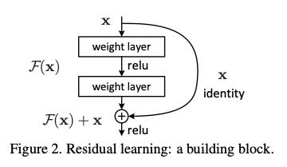

*On the right, ResNet schema*